**Record of Ex. No: 7 –Combination of Solids - I**

**Date of experiment:** 07.06.2021 **Date of submission: 07.06**.2021

**Name:** Kunal Keshan S **Department:** ECE – A **Roll No:** RA2011004010051

**Aim:**

To learn and understand the combination of solids.

**Software used:** AutoCAD.

**Procedure:**

|  |  |
| --- | --- |
| Commands Used | Purpose of Command |
| UNITS | To set the units of the drawings. |
| LIMITS | To set the limits of the drawing area. |
| ZOOM | To adjust the view of the drawing area. |
| LINE | Used to draw a line. |
| POINT | Used to place a point on the drawing area. |
| TEXT | Used to add text in the drawing area. |
| TEXTEDIT | Used to edit any existing text. |
| DIMLINEAR | Used to add linear dimensions. |
| DIMALIGNED | Used to add aligned dimensions (i.e parallel to a line or point that is not perpendicular) |
| DIMANGLE | Used to add dimensions between any two lines or arcs. |
| DDPTYPE | Used to set the type of point and its size. |
| POLYGON | Used to draw a polygon of required number of sides, either inscribed in a circle or the circle in the polygon. Or the polygon can be drawn with respect to its edge length. |
| TRIM | Used to trim off unnecessary parts of the drawing. |
| BOX | Used to draw 3D objects. |
| EXTRUDE | To extrude objects which cannot be make with box. |
| SPHERE | To draw a 3D sphere. |
| CONE | To draw a 3D cone. |
| PYRAMID | To draw a 3D pyramid. |
| UNION | It is used to combine 2D regions or 3D solids by the addition. |
| INTESECTION | 3D solids are formed by the common volume intersection of 2 or more solids. |
| SUBTRACT | 3D solids are formed by subtracting one set of existing 3D solids from another. |
| JOIN | The join command is used to join different objects end to end to create a single object. |
| REVOLVE | It is used a revolve an object about its central axis. |
| REGION | It is used to create 2D areas that are formed inside closed loops. |

**Steps:**

1. Adjust the right units and limits of the drawing area using UNITS AND LIMITS.
2. On the bottom right, select the settings icon and select 3D Modelling.
3. Use the BOX command to draw the solid object or simply click on the box option on the top left corner in home tab.
4. For Polygons, use the POLYGON command to draw one and then use the EXTRUDE command to add height to the polygon.
5. After drawing the primitive solids, use the UNION, INTERSECTION and SUBTRACT commands to perform Boolean operations on the solids accordingly.
6. After adjusting the views of the objects, on the top right corner of the home tab click on views and click on the bottom right arrow to make sure that the projection is in first angle.
7. Then click on the view option again, select base and select from modal space to project the top, front and side view of the solid objects.

**Question 1:**

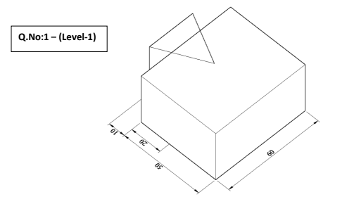

Answer:

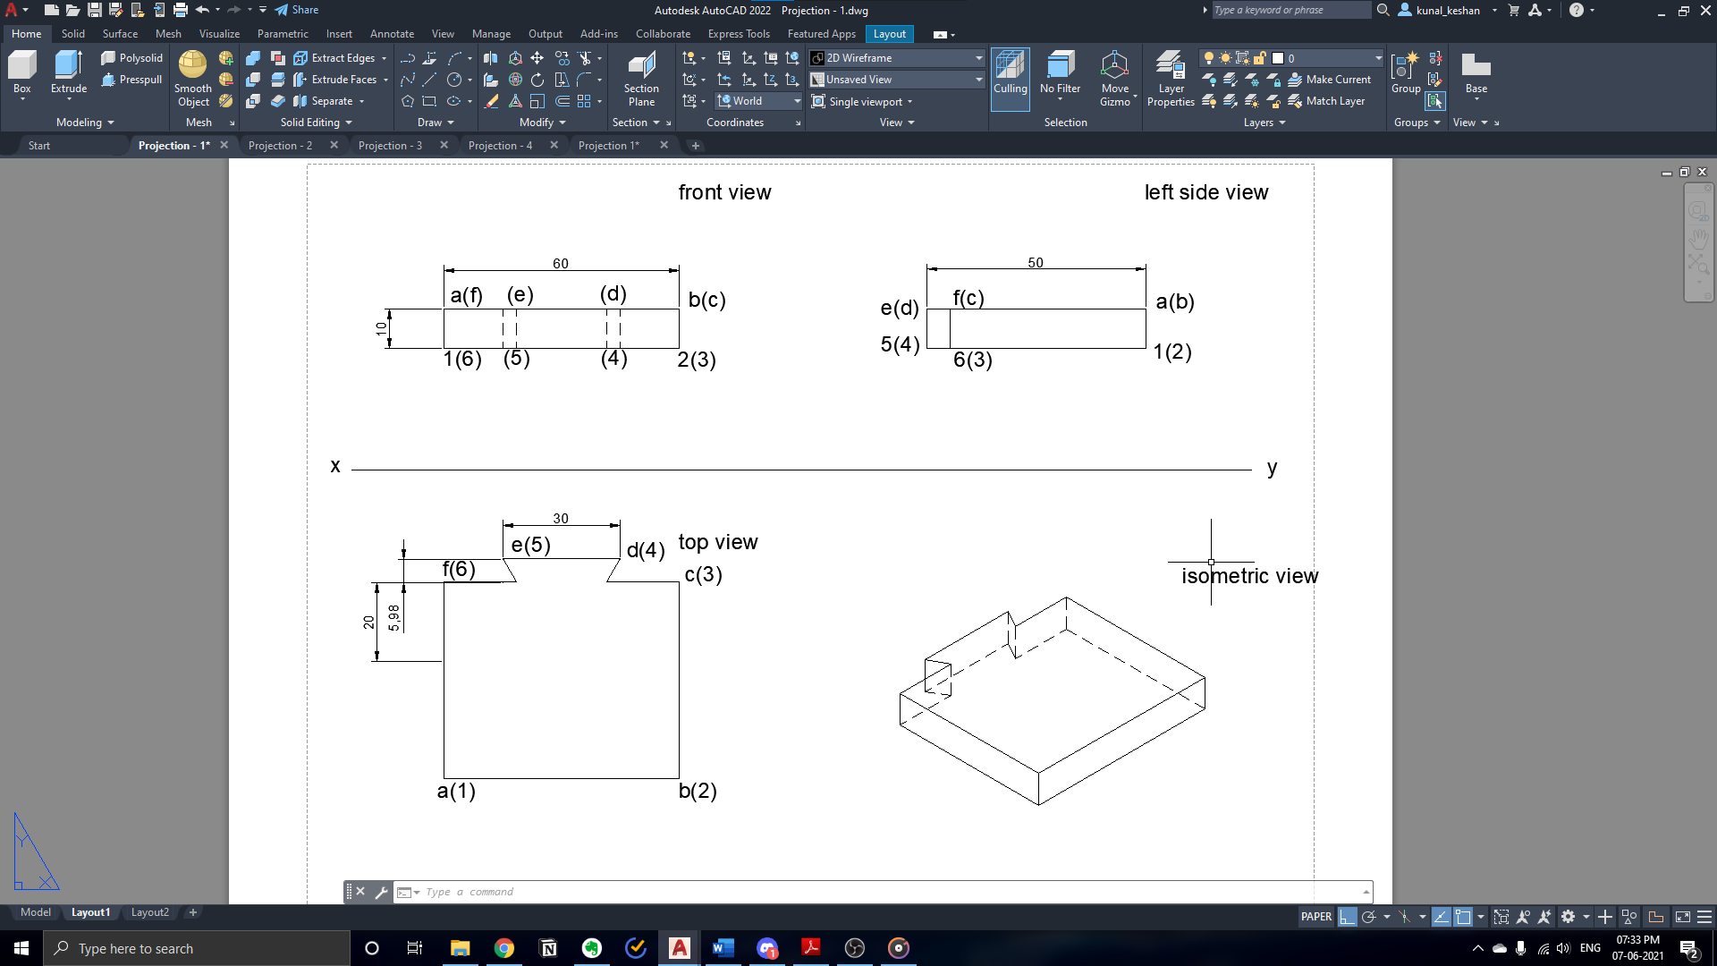

**Question 2:**

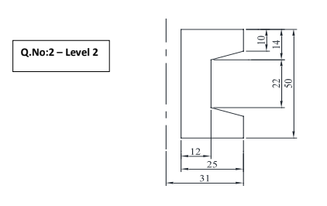

Answer:

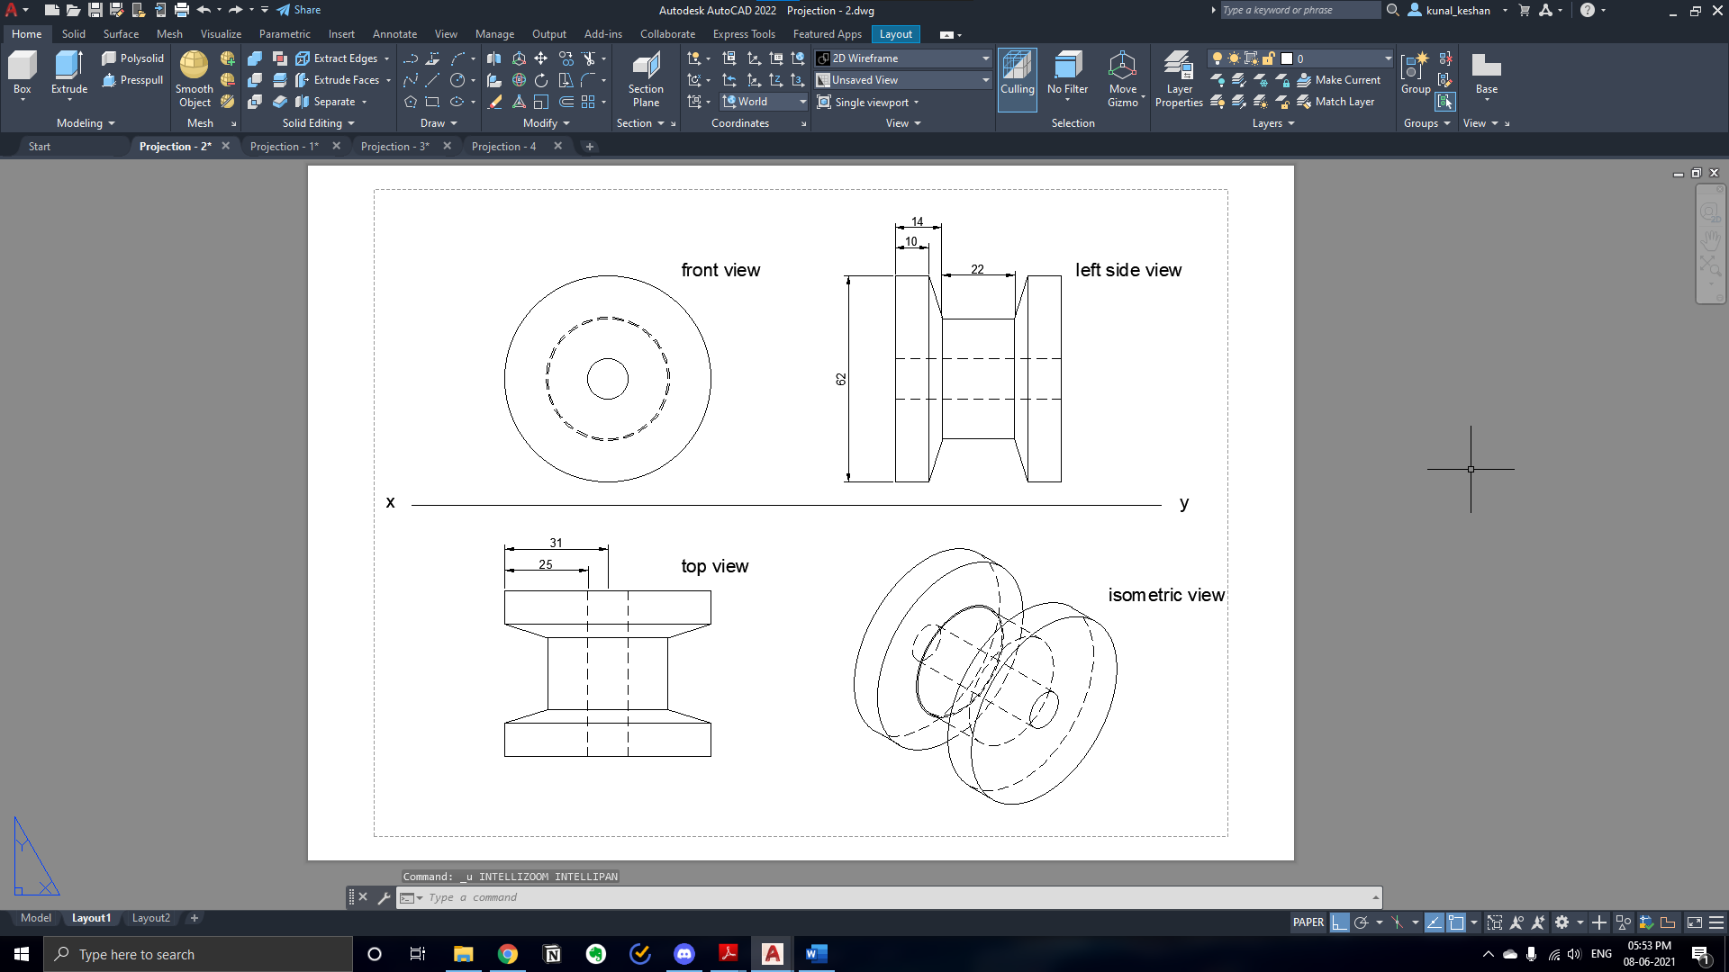

**Questions 3:**

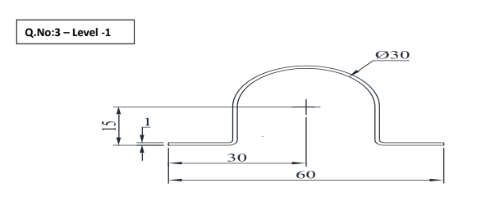

Answer:

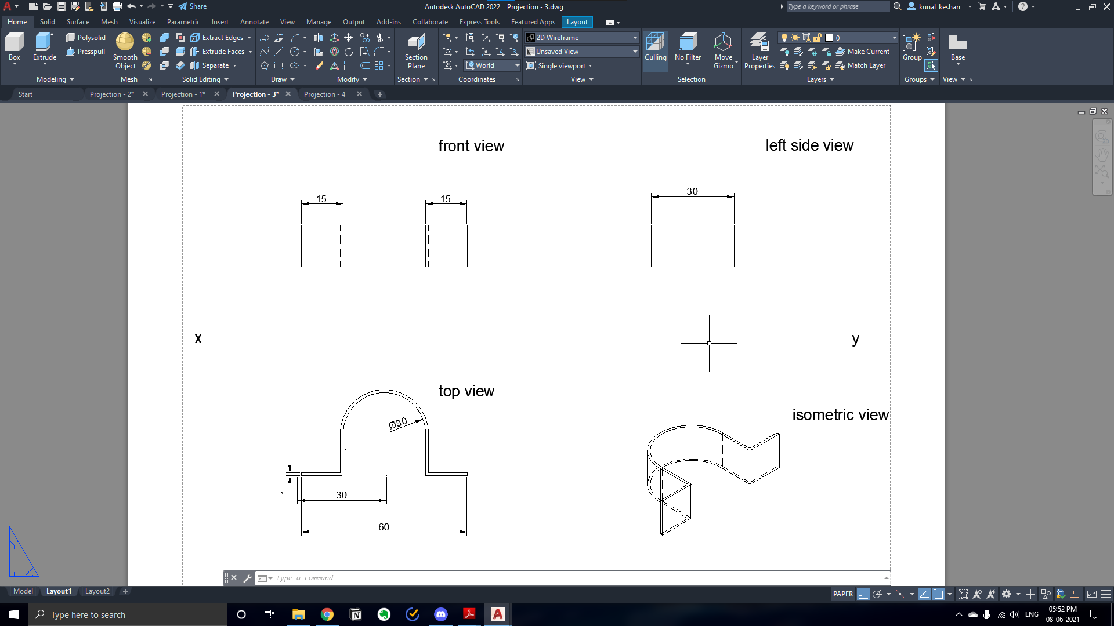

**Questions 4:**

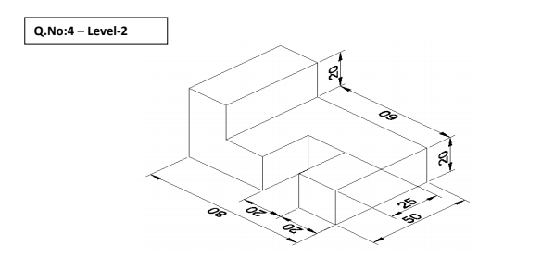

Answer:

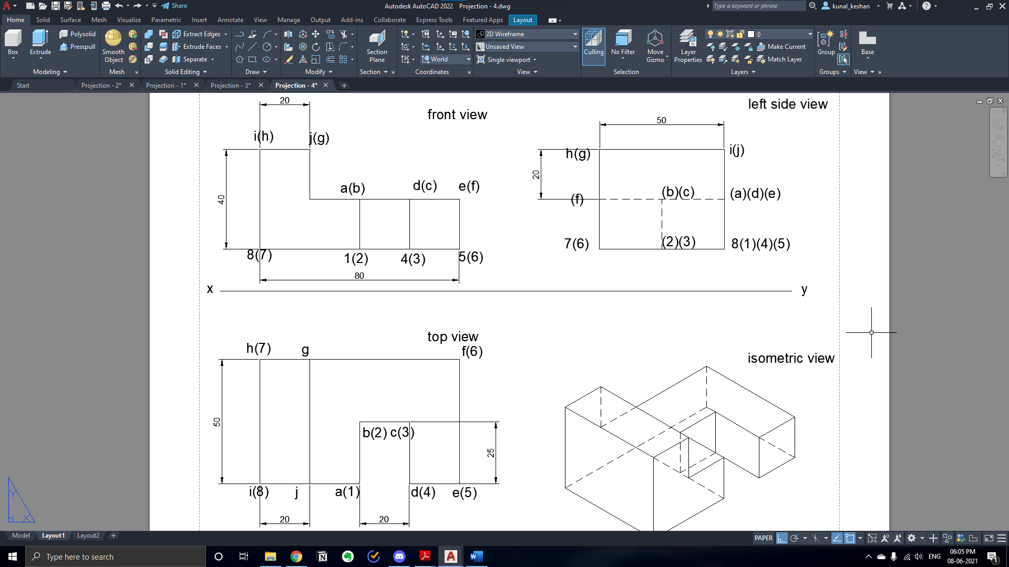

**Result:**

The combination of solids was drawn and projected with the required dimensions.